PHISHING EMAIL DETECTION & AWARENESS REPORT
Prepared By
Satyasai Puppala
Internship
Future Interns – Cyber Security Internship
Date
02 June 2026

Executive Summary
Phishing attacks are one of the most common cyber threats used by attackers to steal sensitive information such as usernames, passwords, banking credentials, and personal data. This project focuses on identifying phishing emails, analyzing suspicious indicators, and creating user awareness regarding phishing attacks.
Three email samples were analyzed and classified as Safe, Suspicious, and Phishing based on their characteristics. The assessment identifies common phishing techniques including domain spoofing, malicious links, and urgency-based social engineering tactics. Recommendations and awareness guidelines are provided to help users recognize and avoid phishing attempts.

Objective
The objective of this project is to analyze email samples, identify phishing indicators, classify emails according to risk level, and provide awareness recommendations to prevent phishing attacks.

Scope
The assessment includes:
- Email sender verification
- Domain analysis
- Link inspection
- Threat classification
- User awareness recommendations

Tools Used
- Email Sample Analysis
- Browser-Based Link Inspection
- Manual Threat Assessment
- Security Awareness Documentation

Methodology
The following methodology was used during the assessment:
- Collection of email samples.
- Review of sender information.
- Inspection of domains and URLs.
- Identification of phishing indicators.
- Classification of email risk levels.
- Documentation of findings and recommendations.

Email Sample Analysis
Email Sample 1 – Safe Email
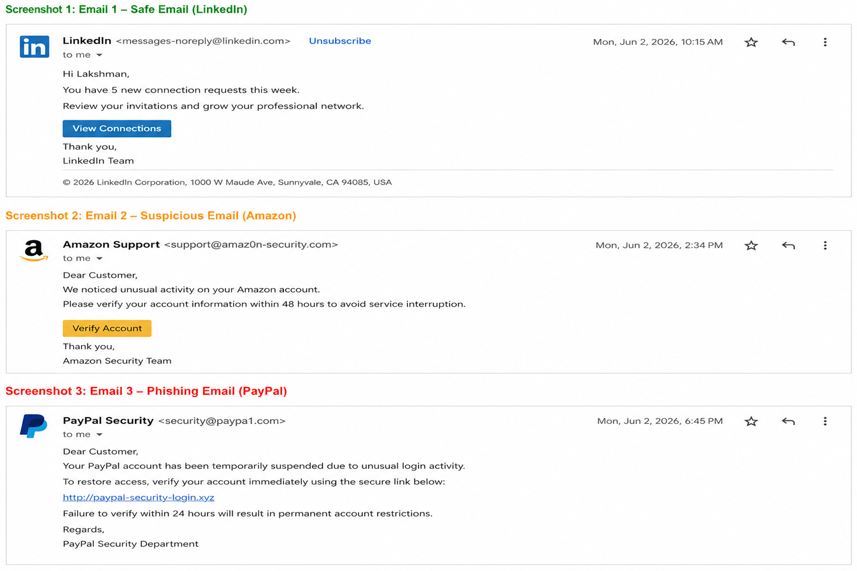
Email Details
From: newsletter@linkedin.com
Subject: New Connections This Week
Hello,
You have received 5 new connection requests.
Visit LinkedIn to review them.
Regards,
LinkedIn Team
Analysis
Indicator | Result
Legitimate Domain | Yes
Suspicious Links | No
Urgency Tactics | No
Grammar Issues | No
Classification | Safe
Description
The email originates from a legitimate domain and contains normal business communication. No suspicious links, spoofed domains, or social engineering tactics were identified.
Risk Level
Low

Email Sample 2 – Suspicious Email

Email Details
From: support@amaz0n-security.com
Subject: Verify Your Account
Dear Customer,
Your account requires verification.
Click the link below to continue.
Verify Account
Analysis
Indicator | Result
Domain Spoofing | Yes
Suspicious Links | Possible
Urgency Tactics | Medium
Grammar Issues | No
Classification | Suspicious
Description
The sender domain attempts to imitate a legitimate company by replacing letters with similar-looking characters. This technique is commonly used in phishing campaigns.
Risk Level
Medium
Recommendation
Users should verify the sender's domain before clicking links and should access services through official websites.

Email Sample 3 – Phishing Email

Email Details
From: security@paypa1.com
Subject: Urgent Account Suspension
Your account has been suspended.
Verify immediately:
http://paypal-security-login.xyz
Analysis
Indicator | Result
Spoofed Domain | Yes
Fake Link | Yes
Urgency Tactics | High
Credential Harvesting Risk | Yes
Classification | Phishing
Description
The email uses a spoofed sender address and directs users to a fake login page. The message creates urgency to pressure victims into taking immediate action.
Risk Level
High
Recommendation
Do not click the provided link. Verify account status through the official PayPal website and report the email as phishing.

Common Phishing Indicators
Domain Spoofing
Attackers often register domains that closely resemble legitimate companies.
Example:
Legitimate Domain:
paypal.com
Spoofed Domain:
paypa1.com

Urgency and Fear Tactics
Phishing emails commonly use urgent language such as:
- Account Suspended
- Immediate Action Required
- Verify Now
- Security Alert
These messages are designed to pressure users into acting without verification.

Malicious Links
Phishing emails frequently contain links that redirect victims to fraudulent websites designed to steal credentials and personal information.
Users should always inspect links before clicking.

Risk Classification Summary
Email Sample | Classification | Risk Level
LinkedIn Newsletter | Safe | Low
Amazon Verification Email | Suspicious | Medium
PayPal Suspension Email | Phishing | High

User Awareness & Prevention Guidelines
- Verify sender email addresses before responding.
- Hover over links before clicking them.
- Avoid downloading attachments from unknown sources.
- Never share passwords through email.
- Enable Multi-Factor Authentication (MFA).
- Verify urgent requests through official communication channels.
- Report suspicious emails to security teams immediately.
- Keep systems and browsers updated.
- Use email filtering and anti-phishing protection tools.
- Participate in regular cybersecurity awareness training.

Conclusion
Phishing remains one of the most effective attack methods used by cybercriminals. Through proper awareness, verification of sender information, and careful inspection of email content, users can significantly reduce the likelihood of becoming victims of phishing attacks.
This assessment successfully identified characteristics of safe, suspicious, and phishing emails while providing recommendations to improve user awareness and cybersecurity practices.

